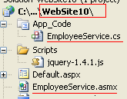

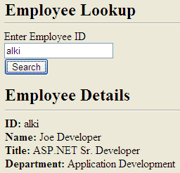

**EmployeeService.asmx**

<%@ WebService Language="C#" CodeBehind="~/App_Code/**EmployeeService.cs**" Class="EmployeeService" %>

**EmployeeService.cs**

using System;

using System.Collections.Generic;

using System.Web;

using System.Web.Services;

[Serializable]

public class Employee

{

public Employee(string empId)

{

//simulate looking up an employee

this.ID = empId;

this.FullName = "Joe Developer";

this.Title = "ASP.NET Sr. Developer";

}

public Employee()

{

}

public string FullName { get; set; }

public string ID { get; set; }

public string Title { get; set; }

}

[WebService(Namespace = "**http://localhost:6752/WebSite10**/")]

[WebServiceBinding(ConformsTo = WsiProfiles.BasicProfile1_1)]

[System.Web.Script.Services.ScriptService]

public class EmployeeService : System.Web.Services.WebService

{

[WebMethod]

public Employee **GetEmployeeById**(string employeeId)

{

//simulate employee name lookup

return new Employee(employeeId);

}

}

**Default**

<%@ Page Language="C#" AutoEventWireup="true" CodeFile="**Default.aspx.cs**" Inherits="_Default" %>

<html xmlns="http://www.w3.org/1999/xhtml">

<head runat="server">

<title></title>

<script src="Scripts/jquery-1.4.1.js" type="text/javascript"></script>

</head>

<body>

<script type="text/javascript">

$(document).ready(function() {

**$("#ButtonSearch").click(function() {**

$("#empDetails").hide("slow");

var empId = $("#TextBoxEmpId").val();

$.ajax({

type: "POST",

dataType: "json",

contentType: "application/json",

url: "**EmployeeService.asmx/GetEmployeeById**",

data: "{'employeeId': '" + empId.toString() + "'}",

success: function(data) {

$("#textId").html(data.d.ID);

$("#textName").html(data.d.FullName);

$("#textTitle").html(data.d.Title);

$("#empDetails").show("slow");

},

error: function() { alert("Error calling the web service."); }

});

});

});

</script>

<form id="form1" runat="server">

<h2>Employee Lookup</h2>

<hr />

Enter Employee ID

<br />

<asp:TextBox ID="TextBoxEmpId" runat="server"></asp:TextBox>&nbsp;

<br />

<input type="button" id="ButtonSearch" runat="server" value="Search" />

<div id="empDetails" style="display: none; margin-top: 40px">

<h2>Employee Details</h2>

<hr />

<b>ID:</b>&nbsp;<span id="textId"></span><br />

<b>Name:</b>&nbsp;<span id="textName"></span><br />

<b>Title:</b>&nbsp;<span id="textTitle"></span><br />

</div>

</form>

</body>

</html>